SQL Learning



Nithish Gowda

Types of joins in SQL  
  
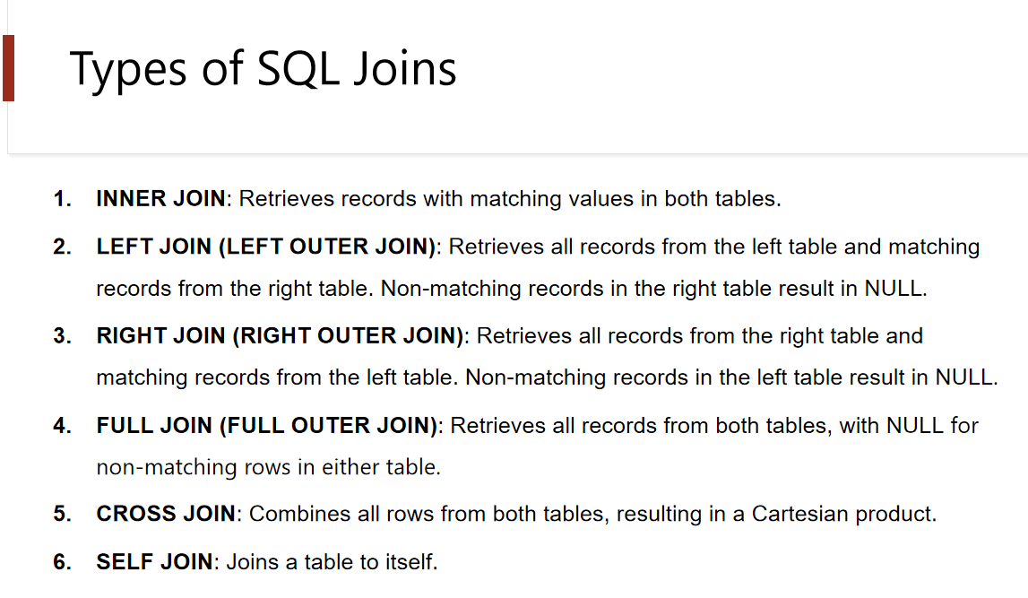

Create tables for the joins session 1 :

-- Create Employees Table

CREATE TABLE Employees3 (

employee_id SERIAL PRIMARY KEY,

first_name VARCHAR(50),

last_name VARCHAR(50),

department_id INT

);

-- Insert Data into Employees

INSERT INTO Employees3 (first_name, last_name, department_id)

VALUES

('Rahul', 'Sharma', 101),

('Priya', 'Mehta', 102),

('Ankit', 'Verma', 103),

('Simran', 'Kaur', NULL),

('Aman', 'Singh', 101);

SELECT * FROM employees3;

-- Create Departments Table

CREATE TABLE Departments (

department_id INT PRIMARY KEY,

department_name VARCHAR(50)

);

-- Insert Data into Departments

INSERT INTO Departments (department_id, department_name)

VALUES

(101, 'Sales'),

(102, 'Marketing'),

(103, 'IT'),

(104, 'HR');

SELECT * FROM Departments;

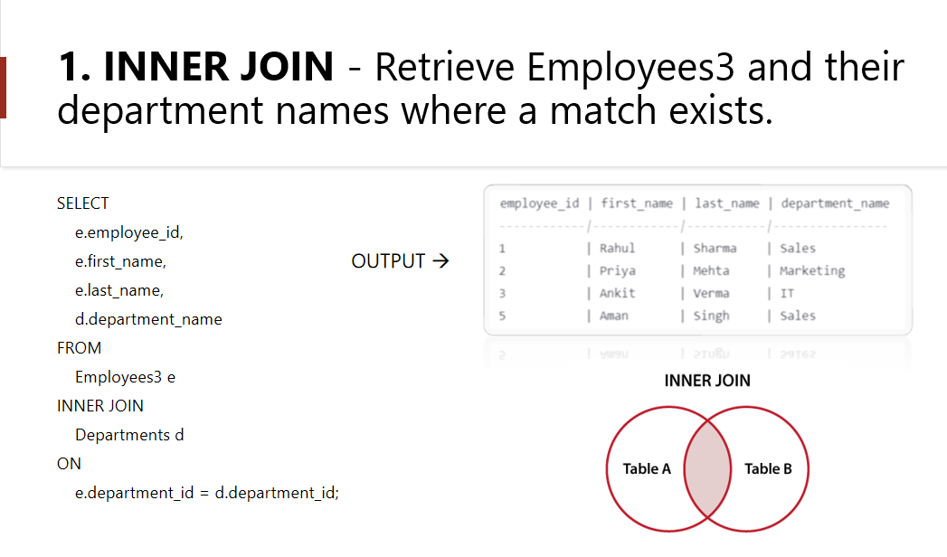

select e.employee_id, e.first_name , e.last_name,

d.department_id, d.department_name

from employees3 e

inner join departments d on

e.department_id=d.department_id;

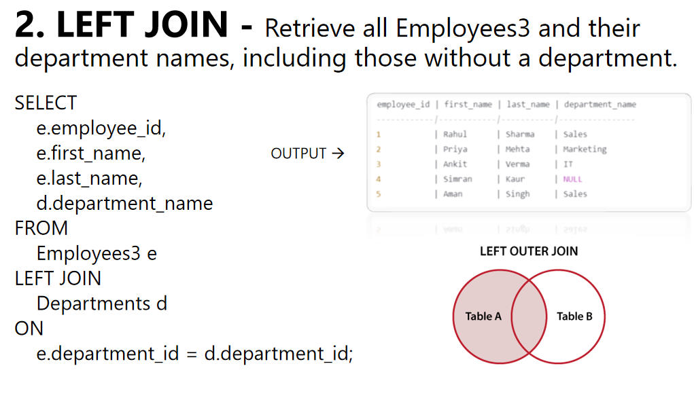

---left join----

select e.employee_id, e.first_name , e.last_name,

d.department_id, d.department_name

from employees3 e

left join departments d on

e.department_id=d.department_id;

Note: In some databases LEFT JOIN is called LEFT OUTER JOIN.

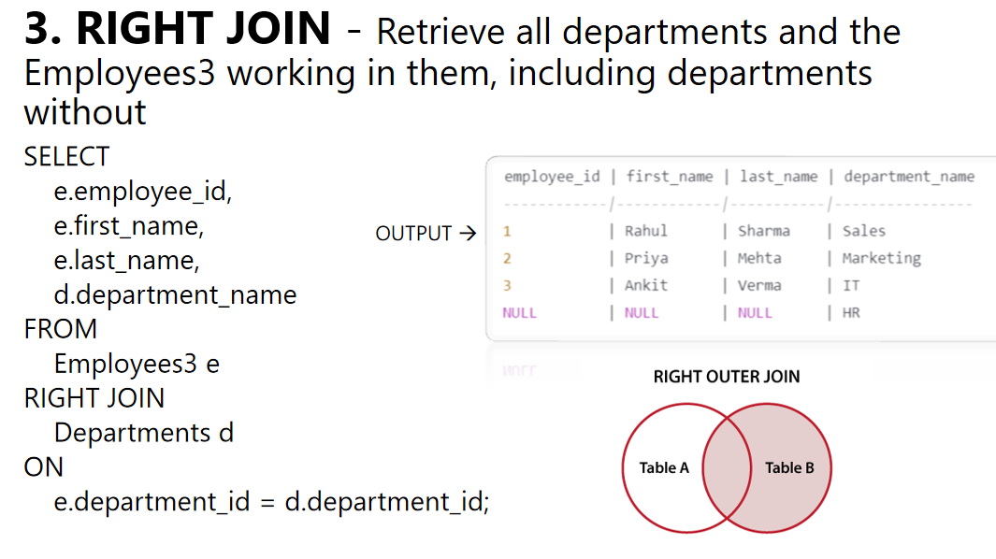

---right join----

select e.employee_id, e.first_name , e.last_name,

d.department_id, d.department_name

from employees3 e

right join departments d on

e.department_id=d.department_id;

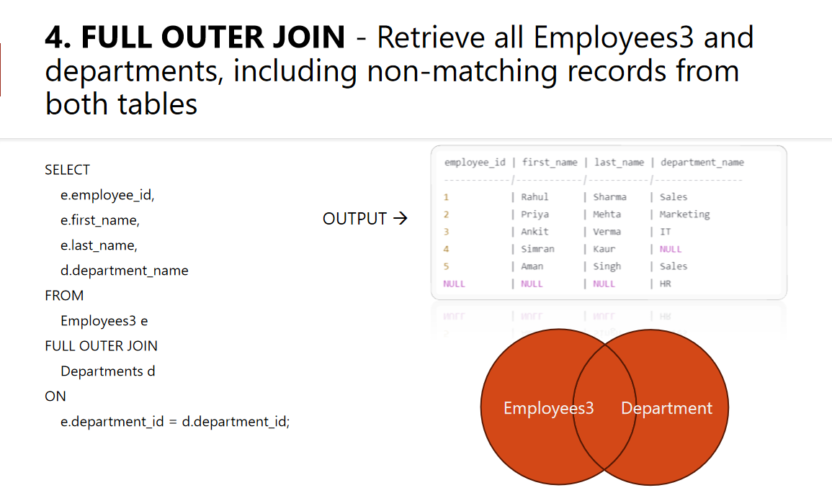

---full outer join---

select e.employee_id,e.first_name, e.last_name,

d.department_id,d.department_name

from employees3 e

full outer join departments d on

e.department_id=d.department_id;

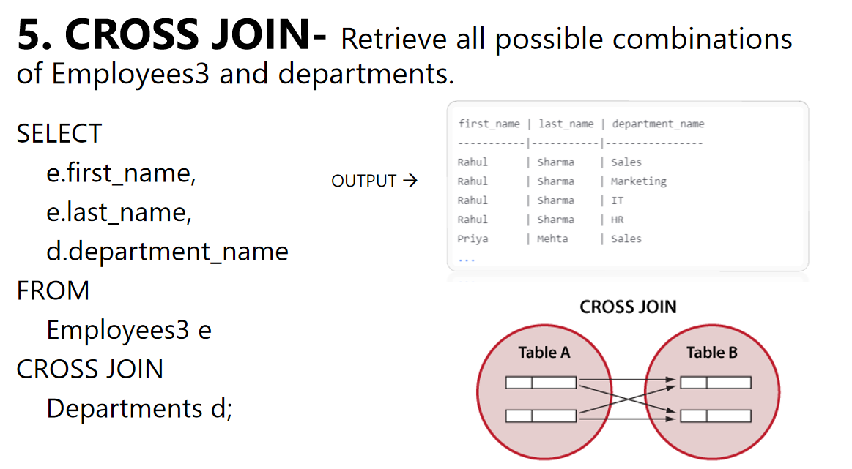

--cross join ---

select e.first_name,e.last_name ,

d.department_name

from employees3 e

cross join departments d;

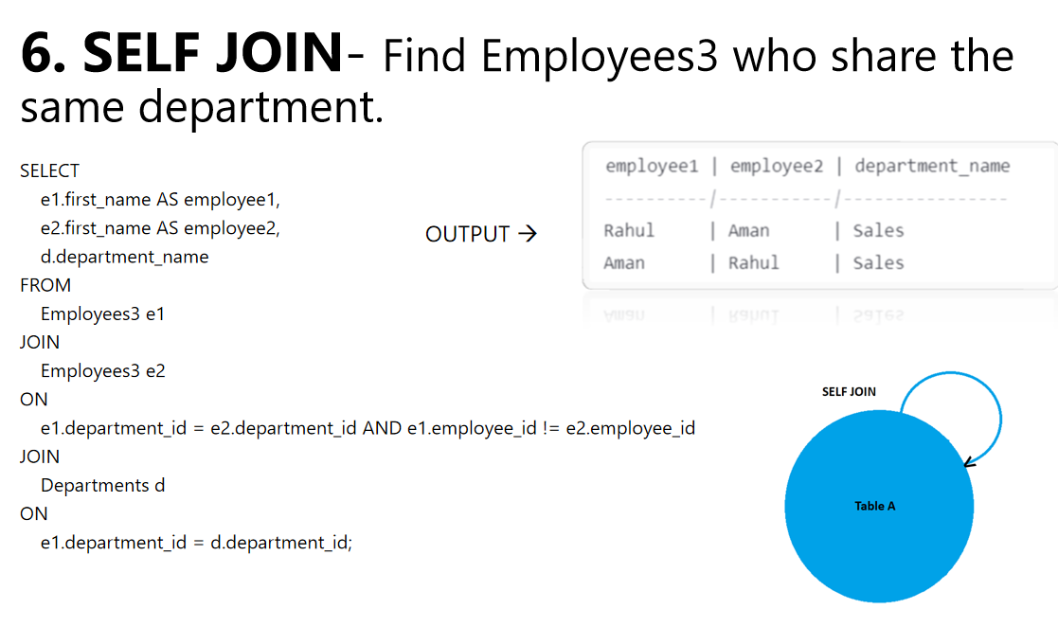

---self join---

select e1.first_name as employee_name1,

e2.first_name as employee_name2,

d.department_name as department_1

from employees3 e1 join employees3 e2

on e1.department_id=e2.department_id and e1.employee_id != e2.employee_id

join departments d

on e1.department_id = d.department_id;